We are preparing to have listening sessions to hear how people like you feel our parishes are doing.

In preparation for this, we have speaking at Masses on the listening sessions. As we introduced the listening sessions, the following was included in the bulletin.

On the second week, we speak about attendance trends. We all know that there are fewer people coming to church now than 20 years ago.  I hope you know that we struggle with financial deficits.  This was presented two weeks ago with the following inserts.

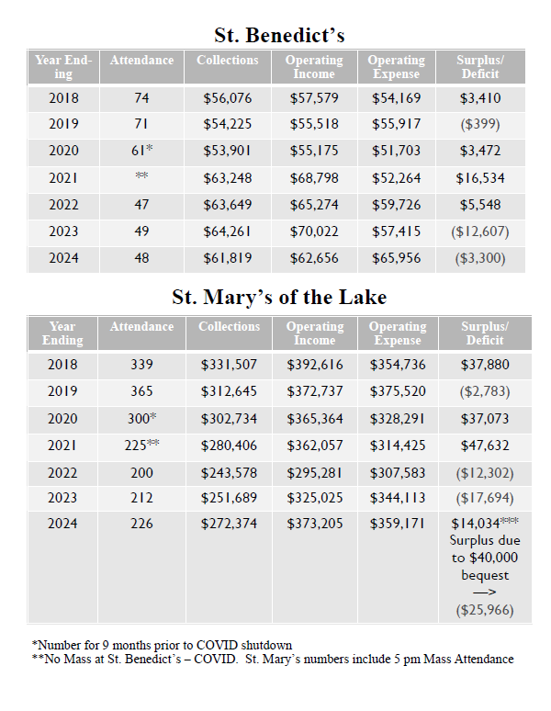

Then, on the third weekend we heard about our building needs. 

We have been working hard to keep our buildings in good shape but there is much work to be done.  Our maintenance staff at St. Mary's and volunteers at St. Benedict's work hard to do what they can.  Yet, there are projects too big for them.

Then, on the fourth weekend, we spoke about our ministries and the works we do.  It is our faith that saves us but when we have faith, we are led to do good works.

As we look to develop a strategic plan for the future of our parishes, we invite you to attend one of two listening sessions.

* Saturday, September 21st – 9:00 am  in the Parish Center at St. Mary's

***or***

* Sunday, September 29th–11:15 am (following Mass) in the Parish Center at St. Mary's

An RSVP is not required but it will help us plan for how many people are coming.  You can let me know which session you will attend by [emailing me at fr.jeffrey.tunnicliff@dor.org](mailto:fr.jeffrey.tunnicliff@dor.org?subject=RSVP%20for%20Listening%20Sessions).  
  
We will begin the listening sessions with a few minutes of highlighting what has been happening and the needs of our parishioners.  Then, the listening sessions will focus on hearing how you think our parishes are doing, your ideas for the future, and how you can help going forward ([page 3 of the bulletin for August 25, 2024](https://stmarystben.us13.list-manage.com/track/click?u=752cd901e208064397034f9bf&id=4422f3832a&e=1e6f6fe49b) had some questions for you to reflect on for this).    
  
Our annual reports will be mailed on Monday, September 19th.  You can read it now on the previous page. I encourage you to read them and to join us at our listening sessions.